**Alation TDC Tool Installation and Configuration**

Approval

| Signatures by each signatory indicate their acceptance that this document is complete and accurate to the best of his/her knowledge per responsibilities outlined in this document and as guided by approved methodologies and established procedures. | | |
| --- | --- | --- |
| Team Lead:  Artha Emp | **Omkar Patil** | **Date:** |
| Project Manager:  Artha Emp | **Pavan Valluri** | **Date:** |
| Talend Developer:  Artha Emp | **Omkar Patil** | **Date:** |

* Downloading The Installer files.

As per Server Request Clients will provide the installer file.

*Redhat servers: - .rpm files

*Ubuntu servers: - .deb files

#Initially clients will send a url with mail to create account and download the Installer file and license file.

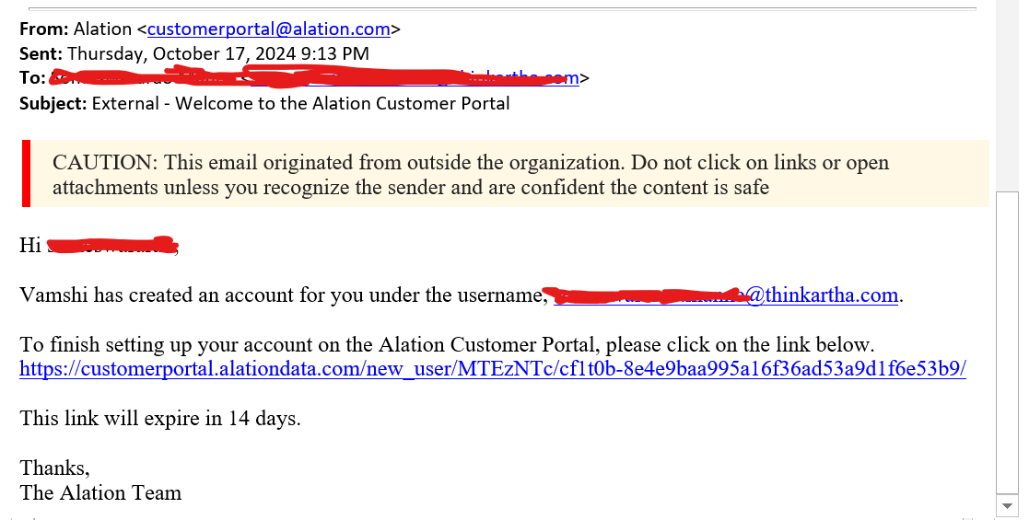

#Login into that link and download the installer and license file.

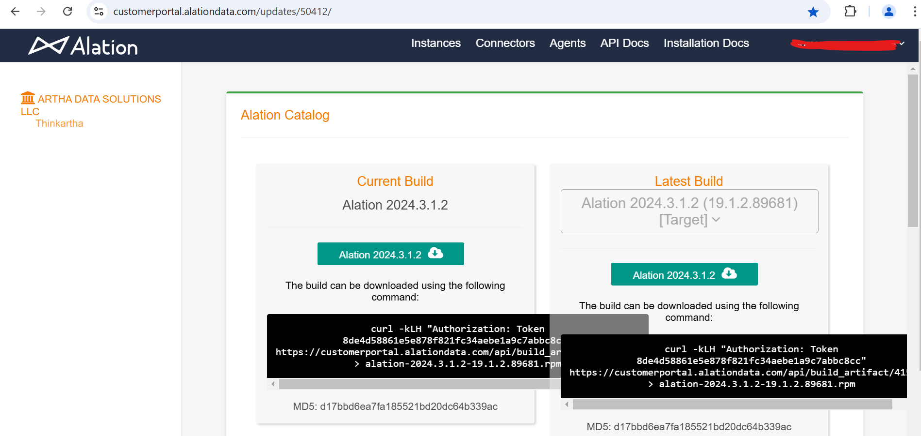Login 🡪 Instances 🡪 Download files 1.installer 2.License

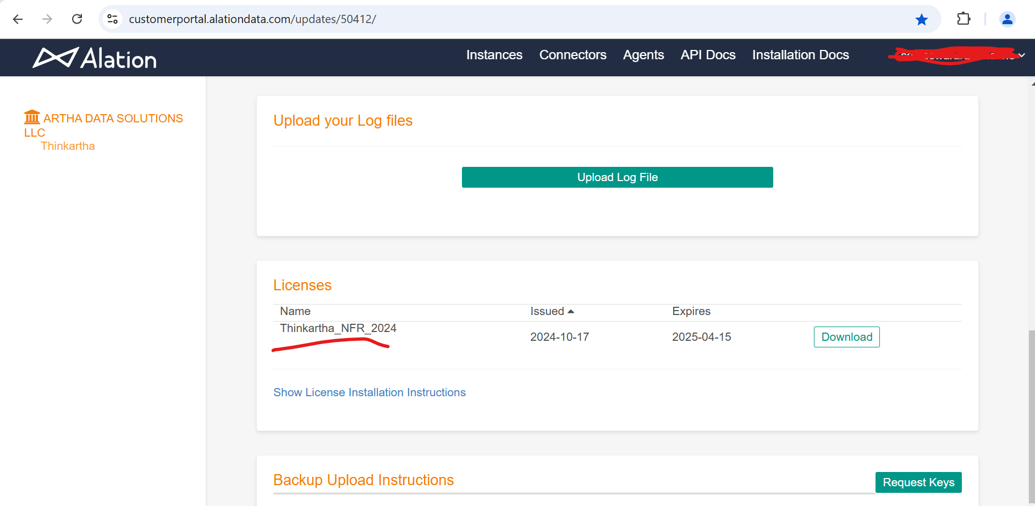

* Preparing for the Installations.

# Installation urls

<https://docs.alation.com/en/latest/installconfig/ServerInstallation/index.html>

#Server configuration url

<https://docs.alation.com/en/latest/installconfig/ServerInstallation/SystemRequirements.html>

#Need separate diskspace which is unmounted to any directory.

#Must compulsory needs to install all the installation as a root user privilege’s.

#Network Requirements open all the mentioned ports.

<https://docs.alation.com/en/latest/installconfig/ServerInstallation/NetworkRequirements.html>

#Check the Installation Readiness and start installation.

<https://docs.alation.com/en/latest/installconfig/ServerInstallation/InstallationReadiness.html>

<https://docs.alation.com/en/latest/installconfig/ServerInstallation/Installation.html>

#Installation doc_2

<https://www.turbogeek.co.uk/using-and-installing-the-alation-data-catalog/#What_are_the_Alation_Pre-Requisites>

<https://www.turbogeek.co.uk/using-and-installing-the-alation-data-catalog/#How_to_install_the_Alation_Data_Catalog>

* Disk partition for Backup and Data directory

#Add the unmount Separate data disk or In Same data disk if you have enough space to create a volume group and partition create it and mount it to data and backup directory.

#Create a volume group on data disk.

#Check the data disk directory.

*lsblk –f

*df -h | grep /data

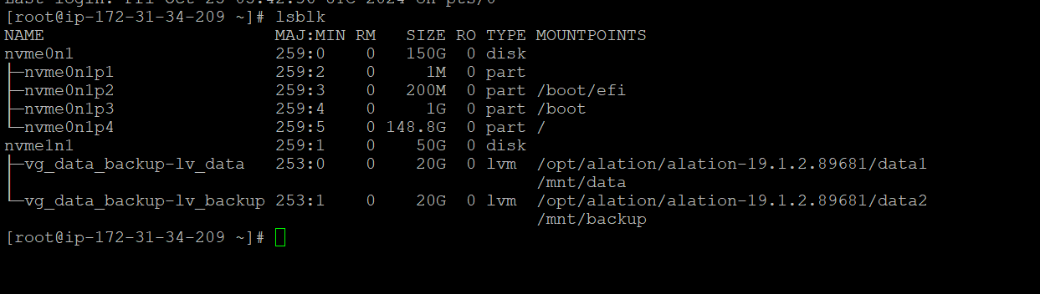

#Check the unmount disk with full space or Create the volume groups in same disk which have enough space.

# Identify the disk

lsblk

# Create physical volume

sudo pvcreate /dev/nvme1n1

# Create a volume group

sudo vgcreate vg_data_backup /dev/nvme1n1

# Create logical volumes

sudo lvcreate -L 20G -n lv_data vg_data_backup

sudo lvcreate -L 20G -n lv_backup vg_data_backup

# Format the logical volumes

sudo mkfs.ext4 /dev/vg_data_backup/lv_data

sudo mkfs.ext4 /dev/vg_data_backup/lv_backup

# Create mount points

sudo mkdir -p /mnt/data

sudo mkdir -p /mnt/backup

# Mount the logical volumes

sudo mount /dev/vg_data_backup/lv_data /mnt/data

sudo mount /dev/vg_data_backup/lv_backup /mnt/backup

# Make mounts persistent (add to /etc/fstab)

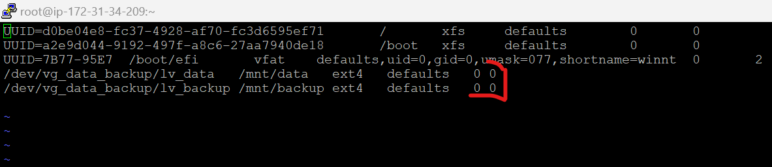sudo vi /etc/fstab

#Add the following lines at the end:

/dev/vg_data_backup/lv_data /mnt/data ext4 defaults 0 0

/dev/vg_data_backup/lv_backup /mnt/backup ext4 defaults 0 0

# Verify the mount points

df -h

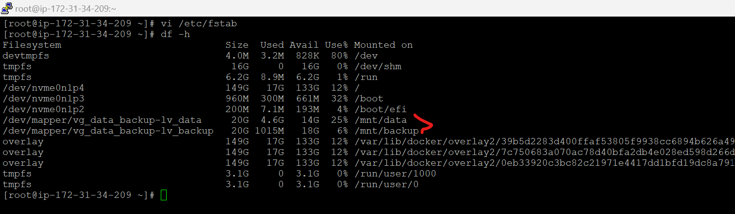

* Start the Installation procedure.

#curl or wget the installation package.

cd /root

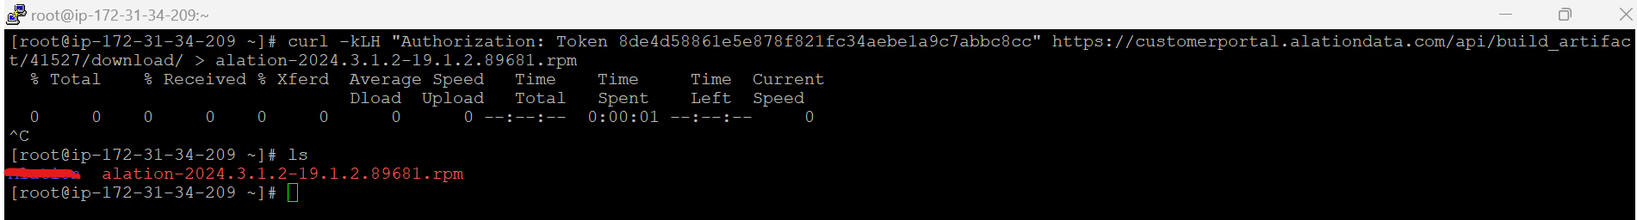curl <package url>

## # Install on Red Hat, Fedora, CentOS, Oracle Linux

1. Move the downloaded RPM file to the host you have prepared for Alation.

2.Confirm the download is good. If the RPM file is corrupted, retry your download.

rpm -K alation-2024.3.1.2-19.1.2.89681.rpm

3. Install the RPM. The installation will take 3-4 minutes.

sudo rpm –ivh alation-2024.3.1.2-19.1.2.89681.rpm

4. Initialize Alation.

sudo /etc/init.d/alation init <data mount point> <backup mount point>

Ex:-

sudo /etc/init.d/alation init /mnt/data /mnt/backup

5. Start Alation.

sudo /etc/init.d/alation start

6.Check status of Alation

sudo /etc/init.d/alation status

7.Restart the Alation

alation_action restart_alation

sudo /etc/init.d/alation restart

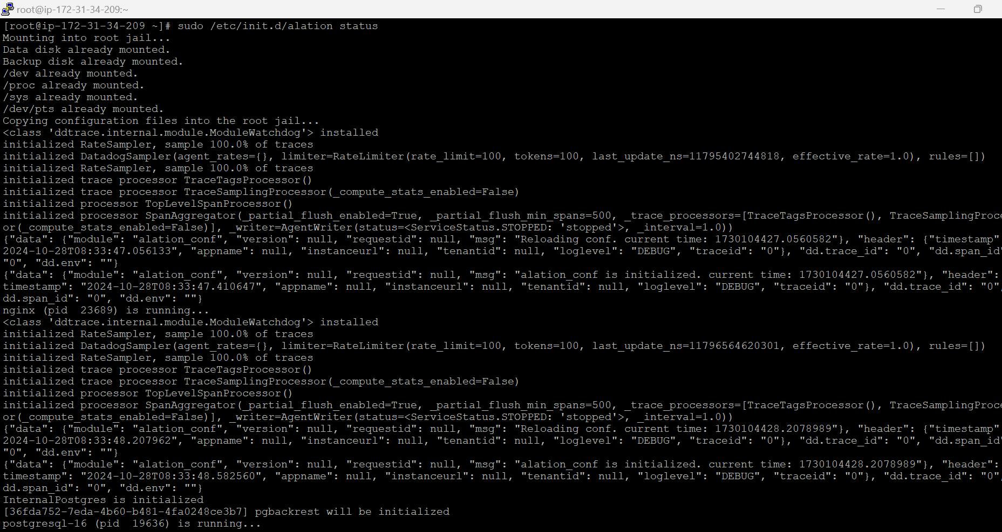

## # Install on Ubuntu, Debian

1.Install the DEB file. The installation will take 3-4 minutes.

sudo dpkg -i alation####.deb

sudo /etc/init.d/alation init <data mount point> <backup mount point>

sudo /etc/init.d/alation init /mnt/data /mnt/backupsudo

sudo /etc/init.d/alation start

* Setting the base url.

1.On the Alation host, enter the shell.

sudo /etc/init.d/alation shell

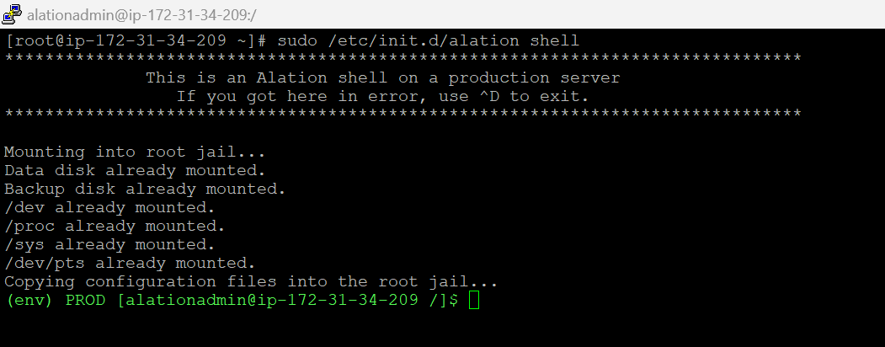

2. Set the URL. Include the http:// or https:// into the value.

* If it Not secure use http it will default run on port 80
* If its Secure use https it will default run on port 443
* Service will be running on Nginx

alation_conf alation.install.base_url -s <new_value>

alation_conf alation.install.base_url -s http://<ip-address>

note :- no need to give the port with Url

3. Confirm the new value.

alation_conf alation.install.base_url

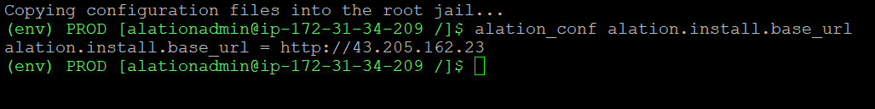

4.Configure some another parameter if its http url.

alation_conf alation.profiling.v2.distribution.show_distribution_chart -s True

alation_conf alation.profiling.v2.distribution.max_unbatched_values -s 10

alation_conf alation.profiling.v2.distribution.batch_count -s 10

alation_conf alation.feature_flags.enable_profiling_v2 -s True

alation_conf alation.taskserver_timeouts.profileColumnV2 -s 120

alation_conf alation.feature_flags.enable_gbm_v2_connector_strategy -s True

alation_conf alation.feature_flags.enable_permissions_middleware_feature -s True

alation_conf alation.feature_flags.enable_swagger -s True

alation_conf alation.authentication.token.disable_v0_api_token_auth -s True

alation_conf alation.feature_flags.enable_lineage_v2 -s True

alation_conf alation.backup_v2.incr_backup -s True

alation_conf alation.backup_v2.incr_backup_versions -s 6

alation_conf alation.install.is_trial -s true

alation_conf nginx.use_ssl -s False

5. Restart the web processes.

alation_supervisor restart web:uwsgi

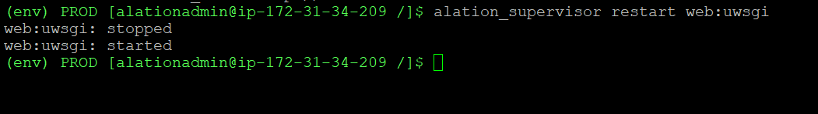

6.Check the Http and https configuration using below url.

<https://docs.alation.com/en/latest/installconfig/ServerInstallation/HTTPS.html?highlight=Enable%20HTTPS#use-load-balancer>

* Setting feature flags.

1. To enter the Alation shell, on the Alation host, run:

sudo /etc/init.d/alation shell

2. To set a flag, use the **alation_conf** command

alation_conf <flag_name> -s <value>

ex:-

alation_conf alation.roles.allow_source_and_catalog_admins_to_create_ds -s True

3. To exit the shell, use:

exit

* Basic server configuration.

#Check the web UI

http://<ip –address>:80

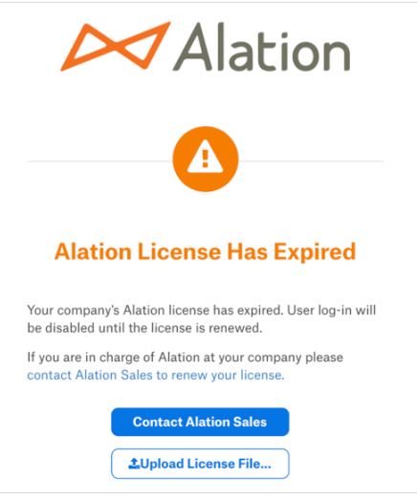

#Upload the license and login create the new user and login with that user.

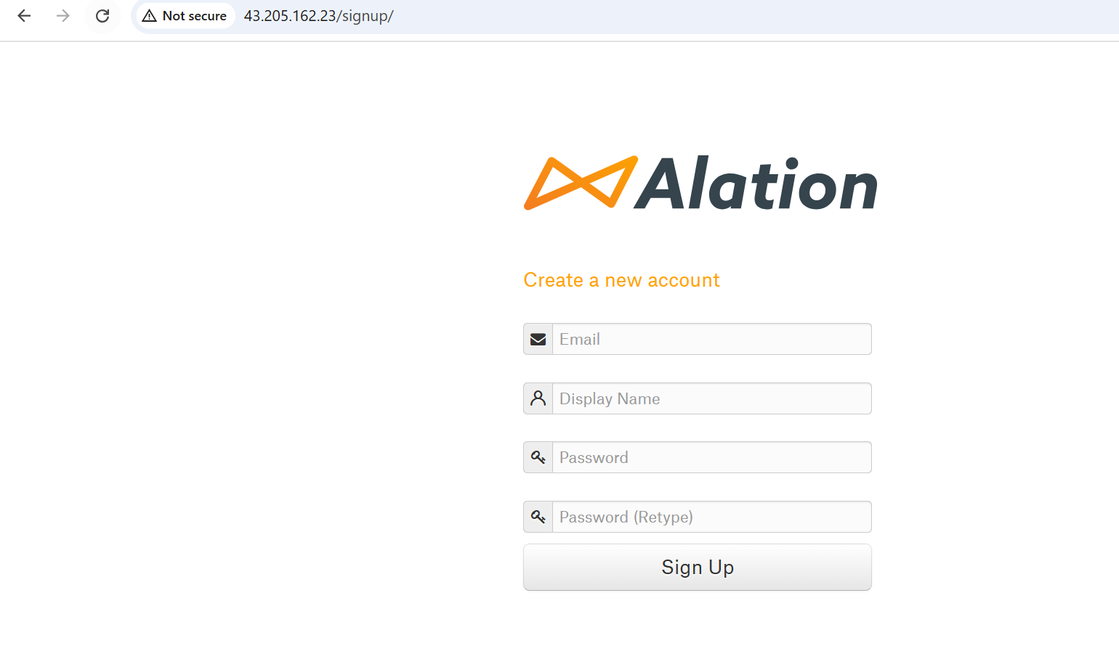

#Login with the created user it will be a Admin User.

Login 🡪 Setting 🡪 users

* Installation of Alation manager to add the Connectors.

<https://docs.alation.com/en/latest/sources/OpenConnectorFramework/OCFInstallAlationConnectorManager.html#installing-ocf-connectors>

## # check Alation connection manager packages on installed directory

.deb for Ubuntu and .rpm for Redhat

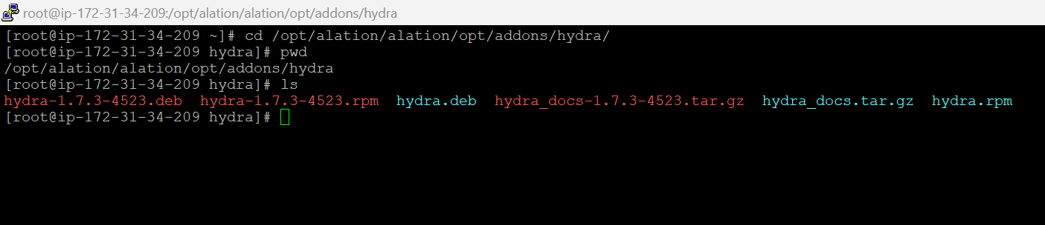

#Installation of Docker.

*Either you can install Docker externally and configure with Alation

Or

*Install Docker using Alation packages.

<https://docs.alation.com/en/latest/installconfig/AlationContainerService/InstallDockerUsingAlationContainerService.html#initial-installation-of-docker>

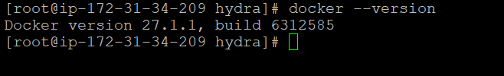

#Install Aaltion connection manager.

sudo yum -y install /opt/alation/alation/opt/addons/hydra/hydra-<version>.rpm

sudo apt install /opt/alation/alation/opt/addons/hydra/hydra-<version>.deb

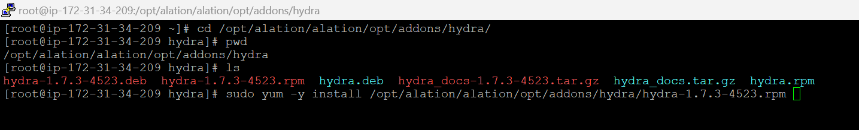

#Configure Alation connection Manager.

1.Open the **hydra.toml** file

sudo vi /etc/hydra/hydra.toml

2.Uncomment the [agent] and address lines and change the address value to use a port number higher than 1024, for example localhost:8181

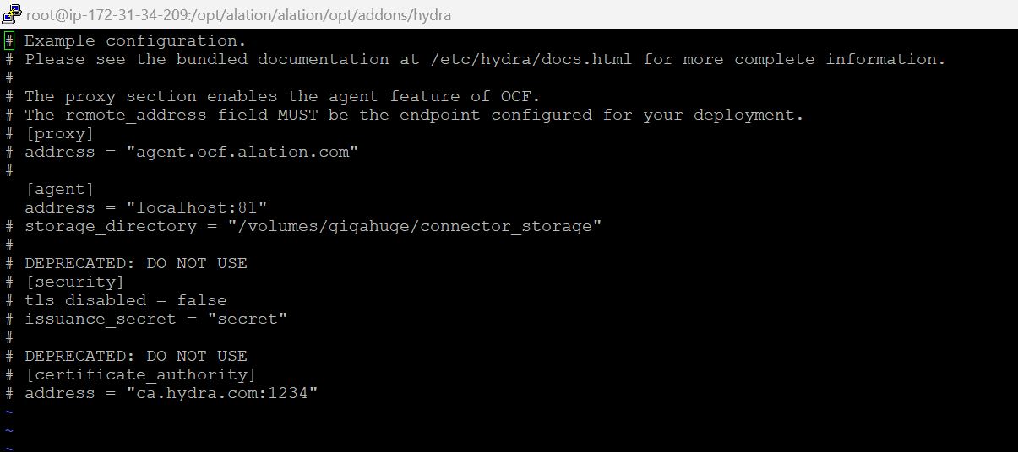

Add the agent address

[agent]

address = "localhost:81"

Note :- Add address = localhost if you add ip address sometimes it won’t work.

#Save the File

#Start Aaltion connection Manager.

1. If Docker has not been started yet, start Docker:

sudo systemctl start docker

sudo systemctl enable docker

sudo systemctl status docker

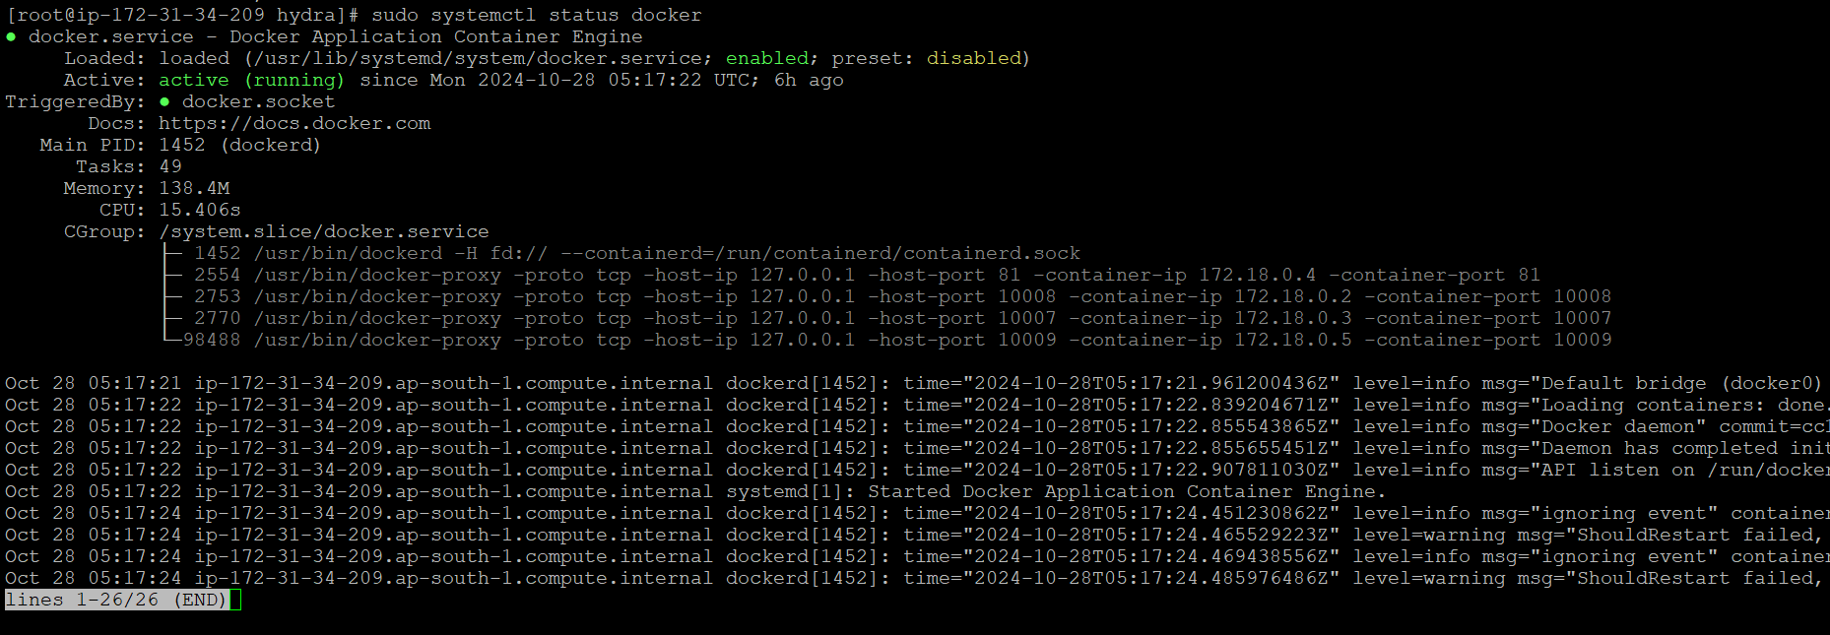

2. Start Alation Connector Manager outside of the Alation shell:

sudo systemctl start hydra

sudo systemctl status hydra

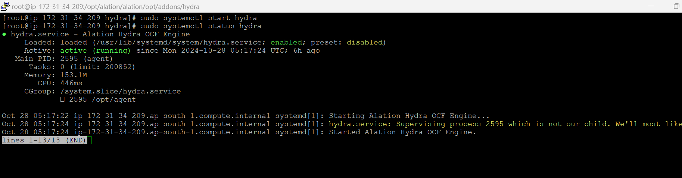

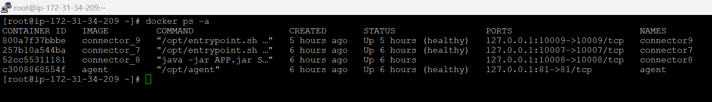# Verify that the agent has started:

### #Configure Alation to Use Alation Connector Manager

# Enter the Alation shell:

sudo /etc/init.d/alation shell

# Only in 2024.1.5 and older, set the following **alation_conf** parameters:

alation_conf alation.hydra_node.agent.hostname -s localhost

alation_conf alation.hydra_node.agent.port -s 81

alation_conf alation.hydra_node.agent.tls_disabled –s True

# Verify that the CLI tool alation_ypireti is operational:

sudo su alation

alation_ypireti list

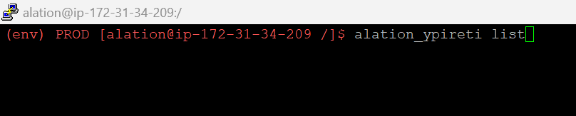

Note : image is for reference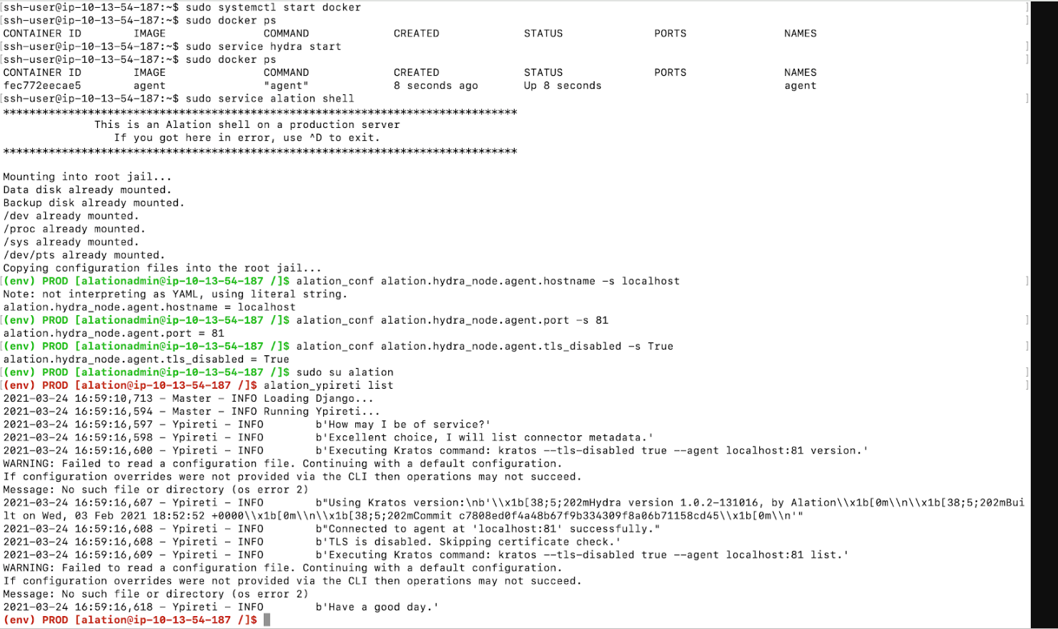

Now that you have successfully installed Alation Connector Manager, you can proceed to install individual OCF connectors.

* Installation of Alation Connectors.

#Installation of Alation Connectors has 2 way

**1. using CLI Install the connectors**

<https://docs.alation.com/en/latest/sources/OpenConnectorFramework/OCFInstallBIConnectors.html>

#Login to Alation Page where we get license and installer file

Login🡪 Click on Connectors 🡪 Download specific connector .Zip file

#Install OCF Connector

* Copy the Zip file with the connector package to a directory on the Alation host accessible from inside the Alation Chroot, for example /tmp
* On the Alation host, install the connector from the Alation shell:

sudo /etc/init.d/alation shell

sudo su alation

cd /tmp

alation_ypireti install --path <connector-x.x.x.x.zip>

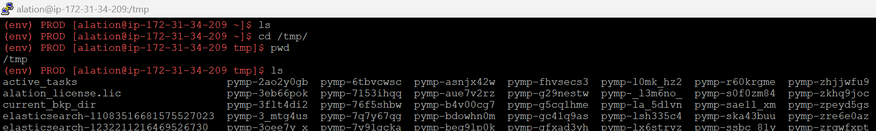

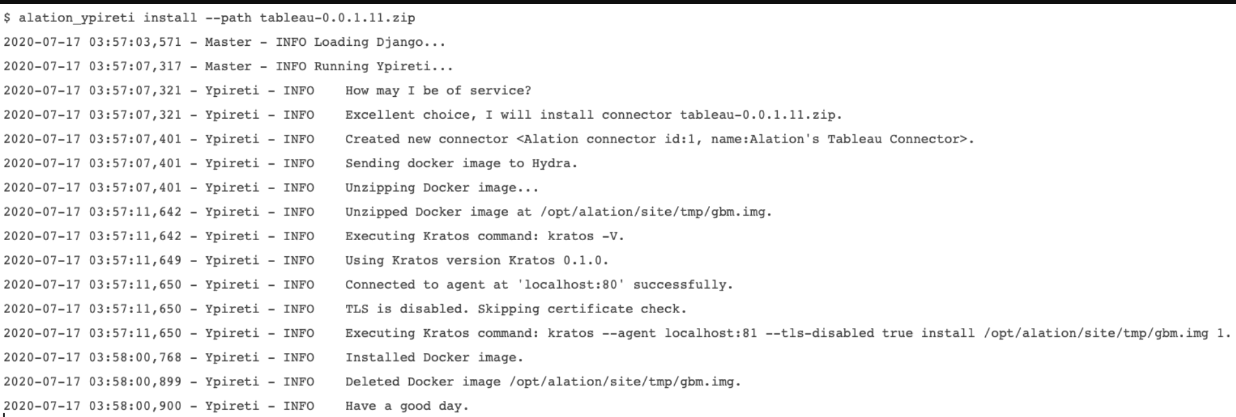

* Enable OCF Connector Usage

alation_conf alation.feature_flags.enable_gbm_v2_connector_strategy –s True

alation_conf alation.feature_flags.enable_lineage_v2 –s True

**2.Using GUI Install the connectors**

<https://docs.alation.com/en/latest/sources/OpenConnectorFramework/ManageConnectors/ManageConnectors.html>

* Goto the Alation shell and Enable these parameters.

alation_conf alation.feature_flags.enable_gbm_v2_connector_strategy –s True

alation_conf alation.feature_flags.enable_lineage_v2 –s True

* Login to Alation Web page.
* Click the Install New Connector button on the Connectors Dashboard page.
* Drag and drop or select the OCF Connector Zip file.
* Once the installation is complete, Alation will display a success message.

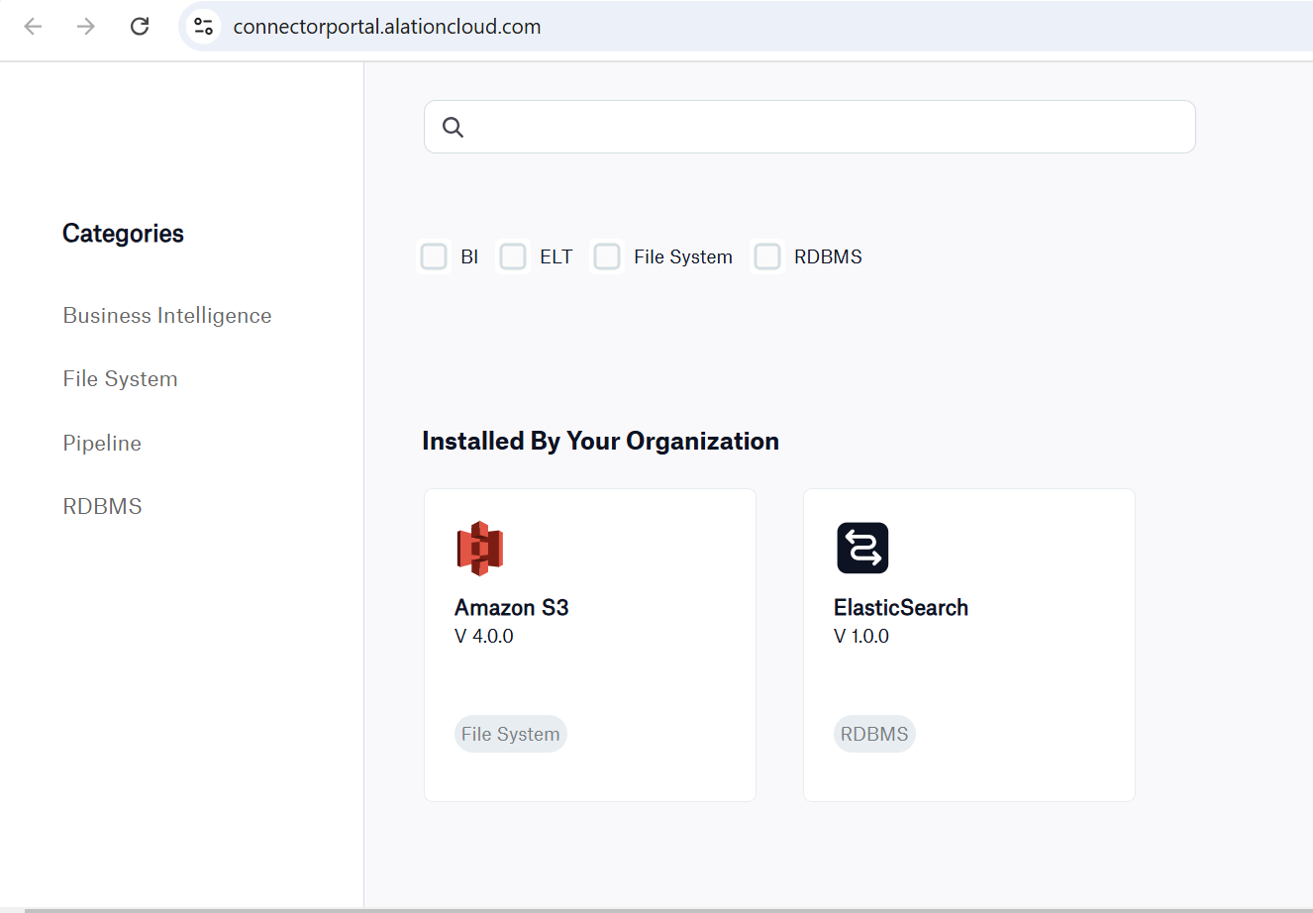

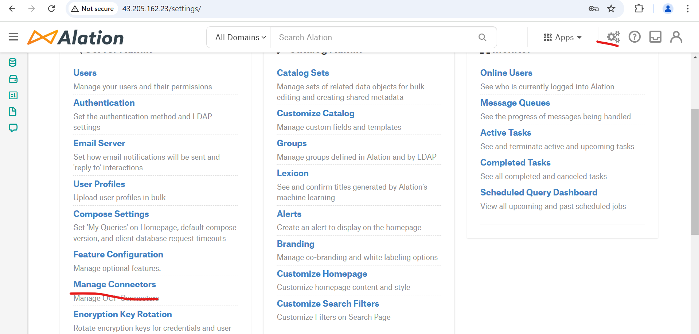

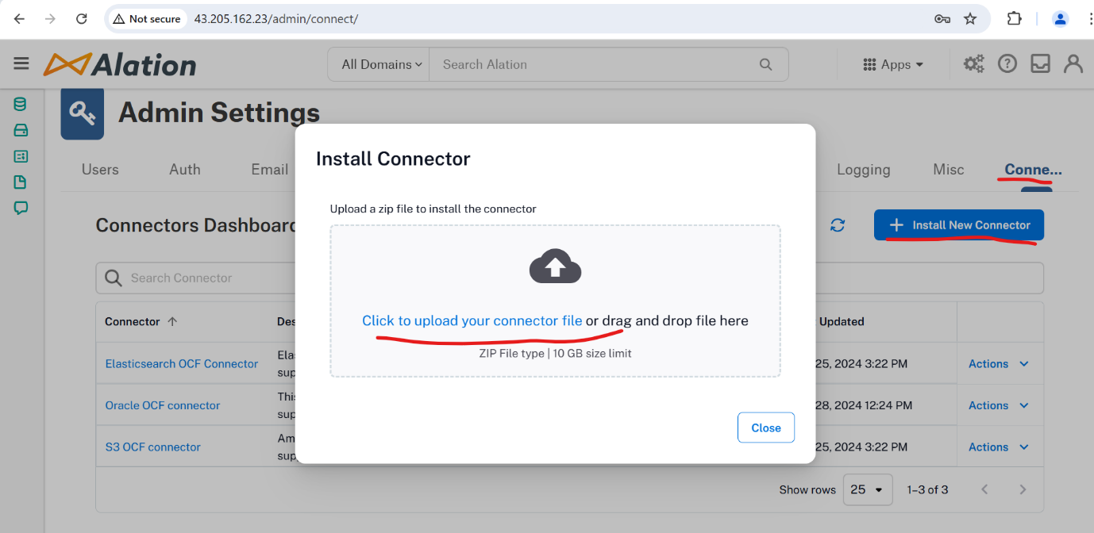

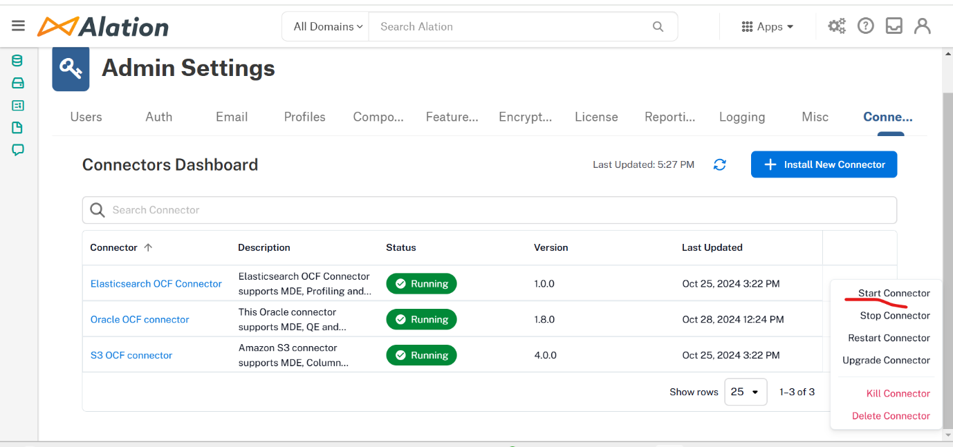

**Preparing Alation Tool AWS server cloud setup with Load balancer and ACM certificate manager**

Step 1:

#Create a AWS Ec2 Instance As per Alation Configuration.

#Attach a unmounted volume disk.

#Allow all the ports as per requirement in AWS Security Group.

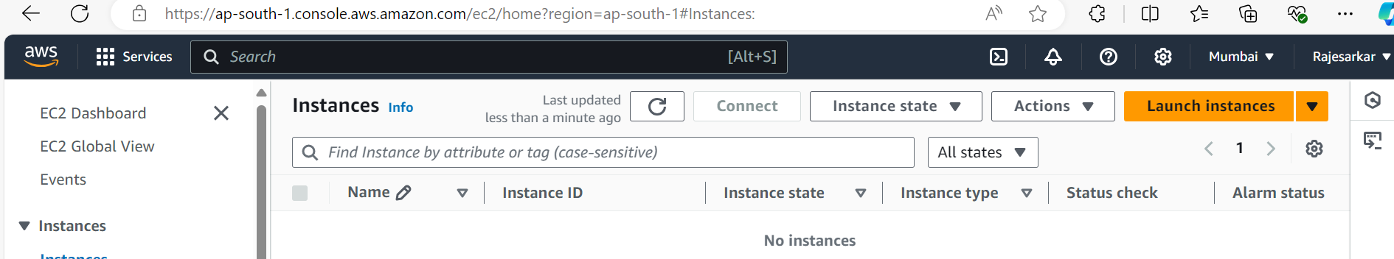

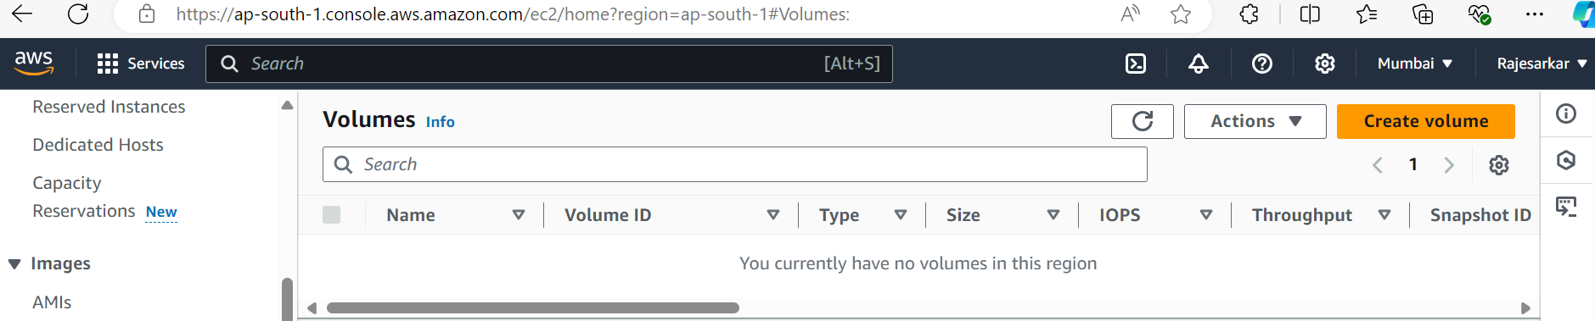

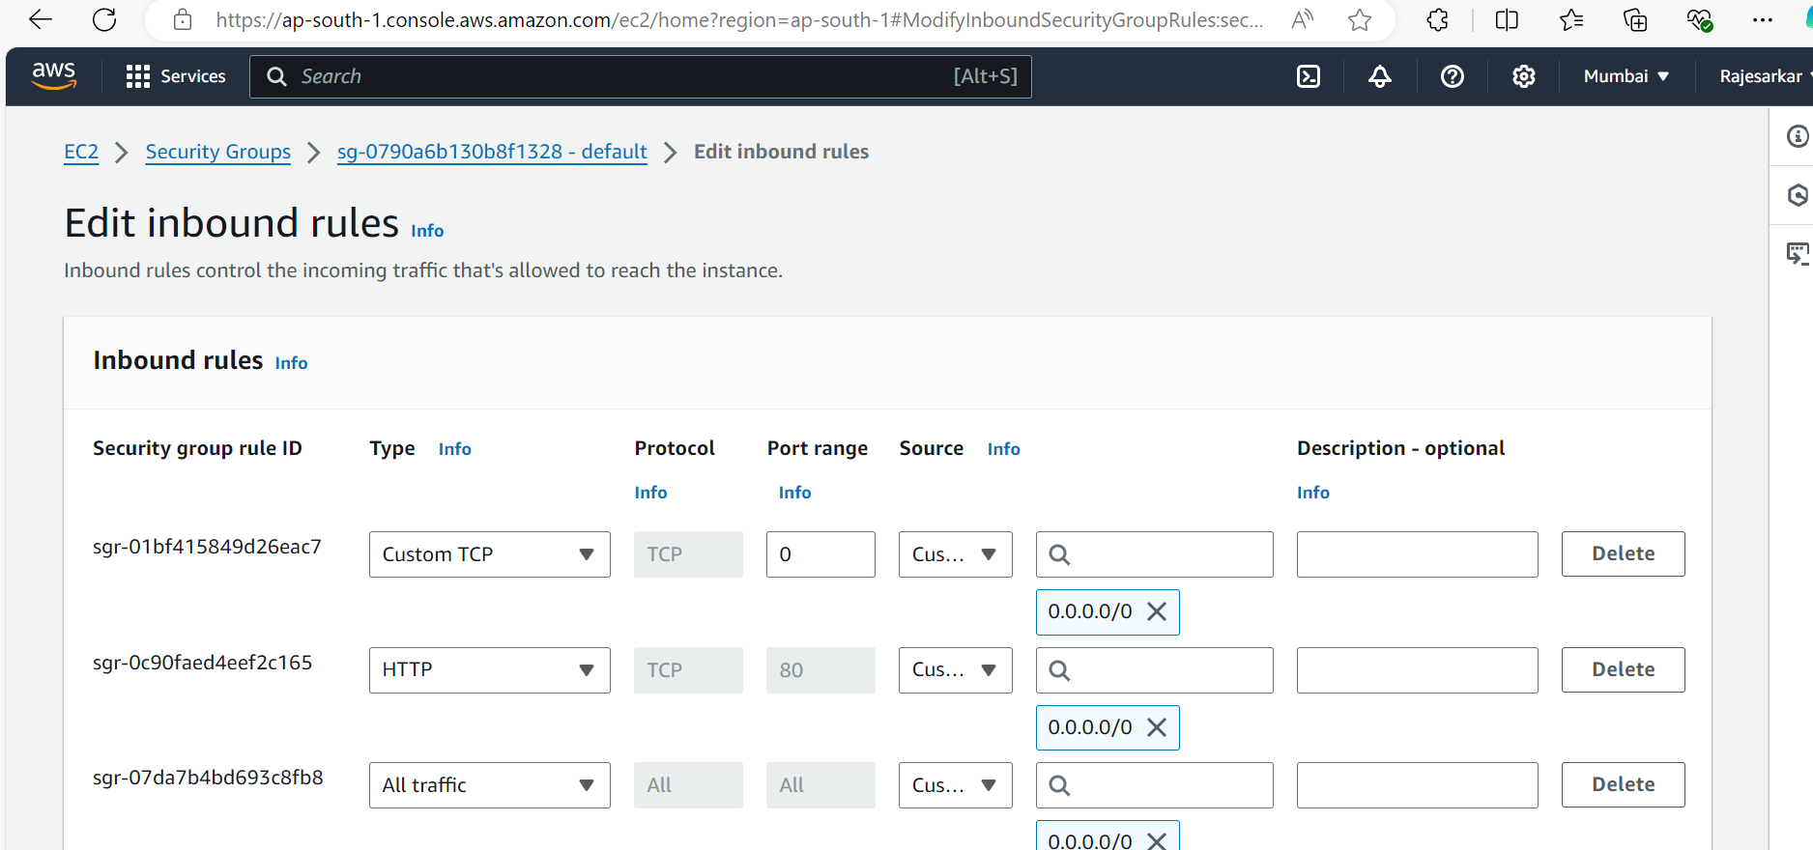

Step 2

#Create https certificate from AWS certificate manager

#Create a AWS certificate and save it.

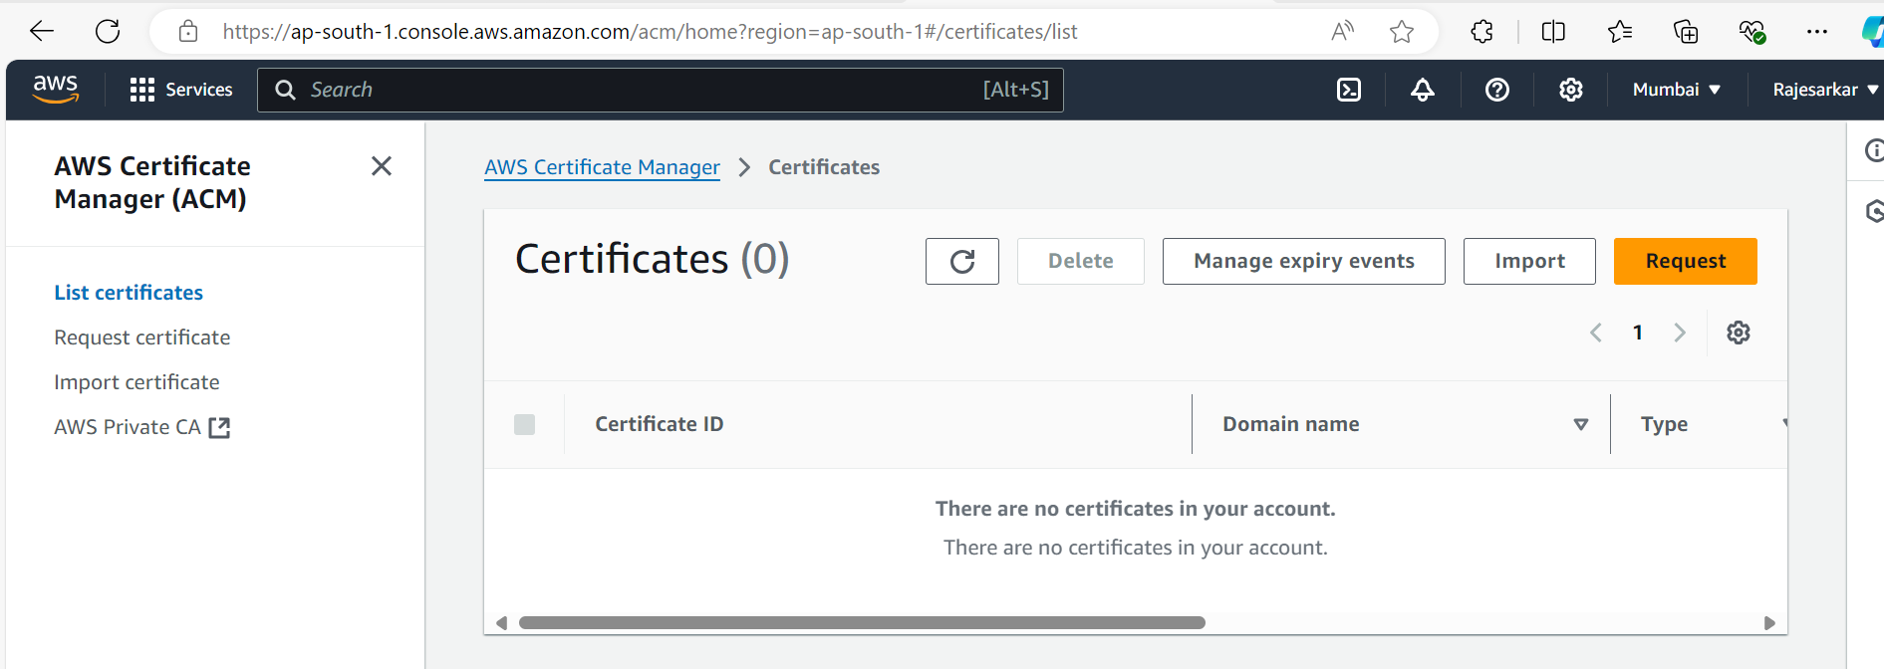

Step 3

#Create Load balancer for AWS EC2 Instance.

#keep it Internet Facing

#Add IPv4 load balancer ip address

#Add security group with all ports open and vpc for subnets.

#Add Listener and Routing of port 443 to the target group

#From Secure listener check below ACM certificate.

#Add the subnets in Load balancer.

#Add the Certificate in Load balancer

#Create a Target group.

#Add Target group to particular instance

#Route the Traffic to port 80 ,443 in Target group.

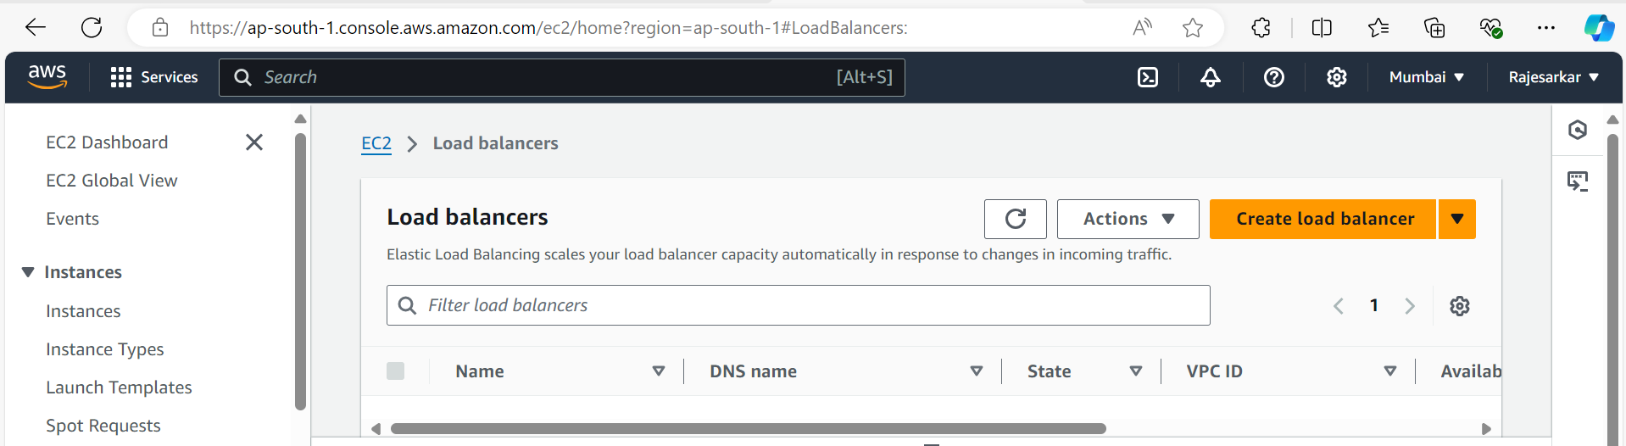

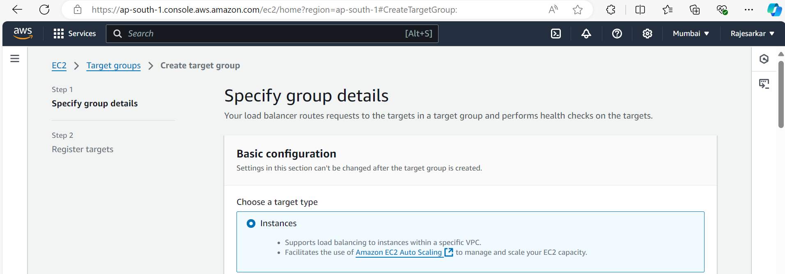

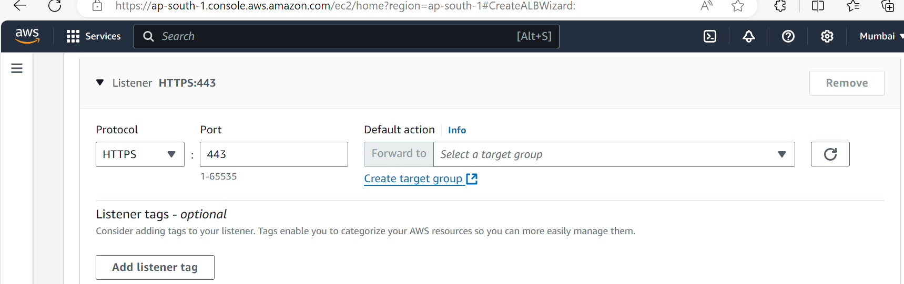

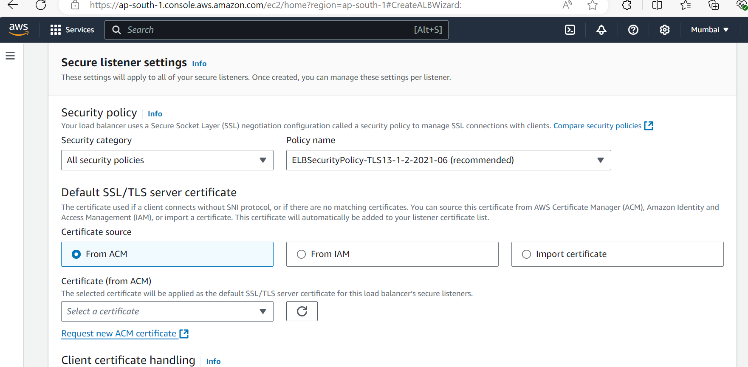

Step 4

#Check Route53 DNS record Hosted Zone.

* **Route53**.
* Choose the corresponding **Hosted Zone**.
* Mark the target **Route53** record.
* Edit record.
* In the section **Route traffic**, we have to choose:
  + 1- Alias to Application and Classic **Load Balancer**.
  + 2- Choose the **region** where the **Load Balancer** exists.
  + 3- In the 3rd field, you have to paste the *load balancer* **endpoint**.

#Use DNS record as a base url of Alation.

